Iterative Refinement & Hallucination Audit using LLM

1. What is an AI Hallucination?
An AI hallucination occurs when a language model generates incorrect, misleading, or completely fabricated information while presenting it as factual.
Example:
- Asking: “Who invented the internet in 2005?”
- AI might answer with a wrong person or made-up explanation, even though the internet existed much earlier.
Causes:
- Lack of real-time knowledge
- Ambiguous or vague prompts
- Overgeneralization from training data
- Missing context

2. How to Audit AI Facts?
Auditing AI output means verifying whether the generated information is accurate and reliable.
Steps:
- Cross-check with trusted sources
  - Google Scholar, Wikipedia, official websites
- Check dates, names, and numbers
- Look for inconsistencies
- Ask follow-up questions
- Use multiple prompts for validation

3. Refinement Log (Main Deliverable)
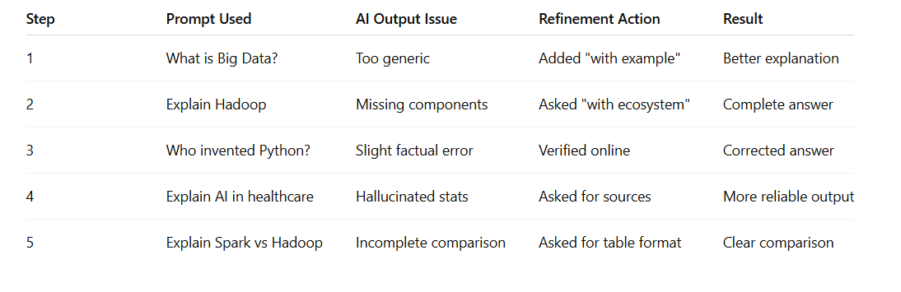

4. Hallucination Audit Summary
Observations:
- AI gives confident but sometimes wrong answers
- Numerical data and facts are most error-prone
- Vague prompts → higher hallucination
Common Hallucination Triggers:
- Ambiguous questions
- Lack of context
- Complex factual queries
- Asking for latest/real-time info
Improvements After Refinement:
- More accurate answers
- Structured responses
- Reduced misinformation

5. Example of Iterative Refinement
Initial Prompt:
Explain Machine Learning
Output: Basic, incomplete

Refined Prompt:
Explain Machine Learning with types and real-world examples
Output:
- Supervised learning (Spam detection)
- Unsupervised learning (Customer segmentation)
- Reinforcement learning (Self-driving cars)
Much better clarity and accuracy

